How to access the SoCalIS e book and audio book collection
1. Click the image above. You will be taken to a drop down menu.
2. From there, choose Chaminade College Prep Middle school, log in with Clever. (faculty, log in with the active directory.
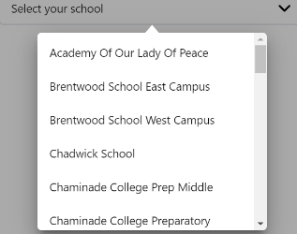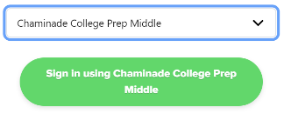
3. On the bottom of the page, click on explore.
This will take you to the page where you can search and set preferences.
To set preferences, click on preferences to help narrow your search.
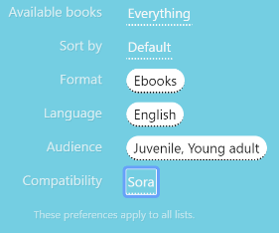
There are several ways to search; the quickest way is to use the search bar.
4. In the search bar, enter the title of a book you hope to find, or the name of a favorite author.
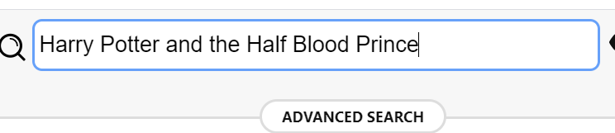
5. If it is available, click on borrow…the book will automatically download and open.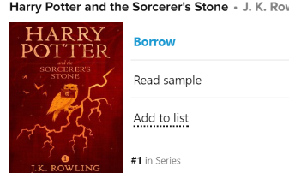
6. If it gives the option of placing a hold, that means someone has it out—if you click place hold, you will be put in the waiting list for the book.
7. You can read this online from your laptop, or another device.
To access from another device, type in soraapp.com/welcome in your web browser. The first time you do this, you may have to identify your school…in this case it is SoCalIS Digital Collection.
If you have an iphone or i ad, you can check with your parent about getting an app for this.
8. To send a book to your Kindle:
Go to your shelf, and click on the title of the book
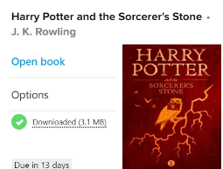
Select send to Device, then send to Kindle.
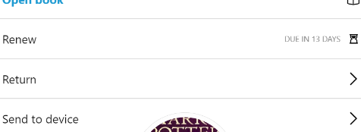
This will take you an Amazon page for this book. From there, select the Get library book, and make sure it is sending to your Amazon device.
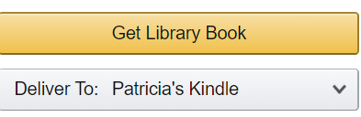
Happy Reading!

